`VIETNAM GENERAL CONFEDERATION OF LABOR

**TON DUC THANG UNIVERSITY**

**FACULTY OF INFORMATION TECHNOLOGY**



**CÔNG NGHỆ PHẦN MỀM**

**FLOWER SHOP MANAGEMENT SOFTWARE**

*Instructing Lecturer*: Mr DANG MINH THANG

*Student’s name*: NGUYEN BA QUYNH – 517H0078

PHUNG TAN DUC – 517H0043

Class : 17050210

Course : 21

**THANH PHO HO CHI MINH, YEAR 2018.**

VIETNAM GENERAL CONFEDERATION OF LABOR

**TON DUC THANG UNIVERSITY**

**FACULTY OF INFORMATION TECHNOLOGY**



**CÔNG NGHỆ PHẦN MỀM**

**FLOWER SHOP MANAGEMENT SOFTWARE**

*Instructing Lecturer*: Mr DANG MINH THANG

*Student’s name*: NGUYEN BA QUYNH – 517H0078

PHUNG TAN DUC – 517H0043

Class : 17050210

Course : 21

**THANH PHO HO CHI MINH, YEAR 2018.**

**ACKNOWLEDGEMENT**

In order to make this report complete and achieve good results, we have received the support and assistance of many teachers and classmates.

With deep affection, sincerity, we express deep gratitude to all individuals and agencies who have helped us in our study and research.

First of all, I would like to express a special appreciation to Ton Duc Thang University’s teachers for their conscientious guidance and advices throughout the last semester by gave me their modern outlook and meticulous supervision to carry out the job perfectly.

Especially we would like to send our sincere thanks to Mr. Dang Minh Thang has paid attention, help, guide us to complete the report well over the past time.

We would like to express our sincere gratitude to the leadership of Ton Duc Thang University for supporting, helping and facilitating us to complete the report well during the study period.

With limited time and experience, this report can not avoid mistakes. We are looking forward to receiving advice and comments from teachers so that we can improve our awareness, better serve the practical work later.

We sincerely thank you!

**THE PROJECT WAS COMPLETED AT TON DUC THANG UNVERSITY**

I pledge that this is a product of our own project and is under the guidance of Dr. Dang Minh Thang. The content of research, results in this subject is honest and not published in any form before. The data in the tables used for the analysis, comment, and evaluation were collected by the authors themselves from various sources indicated in the reference section.

**If any fraud is found, I am fully responsible for the content of my project.** Ton Duc Thang University is not involved in any copyright infringement or copyright infringement in the course of implementation (if any).

*TP. Ho Chi Minh, ngày tháng năm 2019*

*Tác giả*

(ký tên và ghi rõ họ tên)

*Đã kí*

Nguyen Ba Quynh

*Đã kí*

Phung Tan Duc

**EVALUATION OF INSTRUCTING LECTURER**

**Confirmation of the instructor**

_______________________________________________________________________________________________________________________________________________________________________________________________________________________________________________________________________________________________________________________________________________________________________________________________________________

Tp. Ho Chi Minh, ngày tháng năm 2019

(kí và ghi họ tên)

**The assessment of the teacher marked**

_______________________________________________________________________________________________________________________________________________________________________________________________________________________________________________________________________________________________________________________________________________________________________________________________________________

Tp. Ho Chi Minh, ngày tháng năm 2019

(kí và ghi họ tên)

**INTELLECTUAL PROPERTY**

The following documentation, the content therein and/or the presentation of its information is proprietary to and embodies the confidential processes, designs, technologies and otherwise of . All copyright, trademarks, trade names, patents, industrial designs, and other intellectual property rights contained herein are, unless otherwise specified, the exclusive property of my team.

The ideas, concepts and/or their application, embodied within this documentation remain and constitute items of intellectual property which nevertheless belong to my team.

The information (including, but by no means limited to, data, drawings, specification, documentation, software listings, source and/or object code) shall not be disclosed, manipulated, disseminated or otherwise in any manner inconsistent with the nature and/or conditions under which this documentation has been issued.

The information contained herein is believed to be accurate and reliable. My team accepts no responsibility for its use in any way whatsoever. Team Five shall not be liable for any expenses, damages and/or related costs which may result from the use of the information contained herein.

The information contained herein is subject to change without notice.

All Rights Reserved. Copyright herein is expressly protected at common law, statute and under various International and Multi-National Treatises (including, but by no means limited to, the Berne Convention for the Protection of Literary and Artistic Works).

**ABSTRACTS**

This document provides an in – depth analysis of a seafood restaurant management software with the requirements modelled utilizing the UML framework. The document is a collaboration between the numbers of my team.

**Table of Contents**

INTELLECTUAL PROPERTY................................................................................................... 6

ABSTRACTS ...............................................................................................................................7

**Table of Contents ........................................................................................................................8**

1. Requirements engineering........................................................................................................ 9

2. Use case specification and diagrams ………………….. .................................................. 9, 10

3. Class diagrams.........................................................................................................................10

4. Activity/Sequence diagrams ..................................................................................................11

5. Entity relationship diagram ....................................................................................................11

6. Relational data model..............................................................................................................12

1. Requirements engineering:

* User requirements:

+ A system shall allow the users to register by entering their username and password, In order to get an access to the system.

+ A system should allow user log in website and buy flower.

+ A system should archive data of user and purchase history.

+ A system should be diversified payment methods.

* System requirements:

+ On the last working day of each month, a summary of the flowers sold.

+ The system shall generate the report for printing after 17.30 on the last working day of the month.

+ The system can be allowed down 2 hours per month.

1. Use case specification and diagrams:

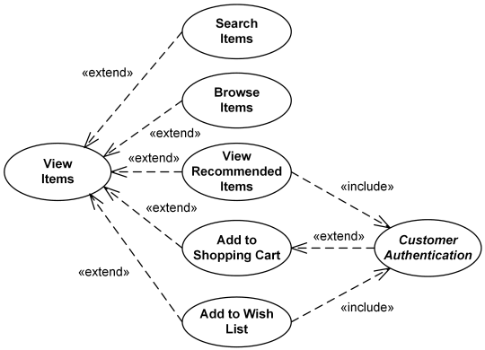

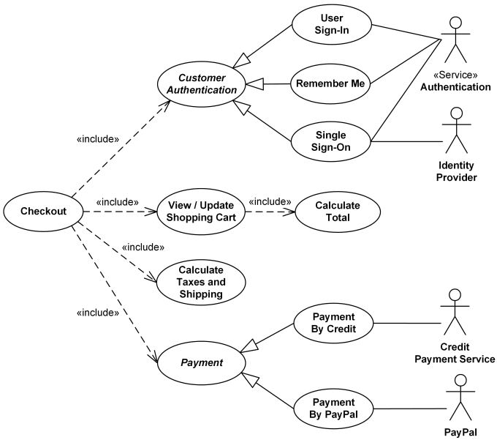

1. Class diagrams:

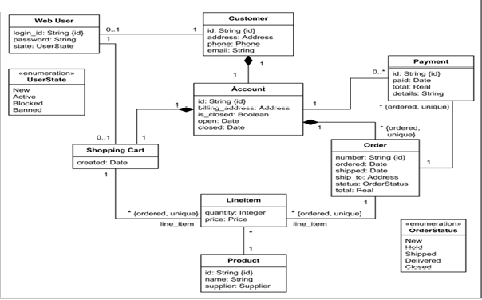

1. Activity/Sequence diagrams:

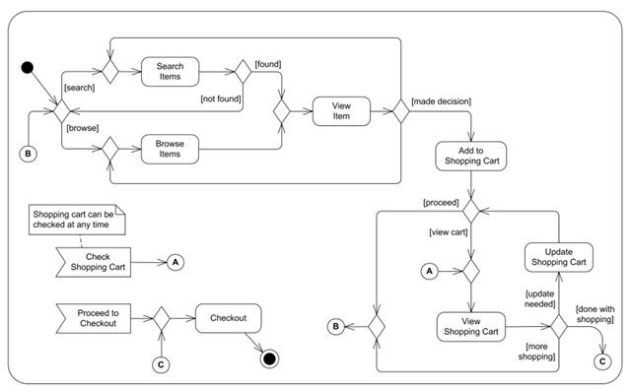

1. Entity relationship diagram:

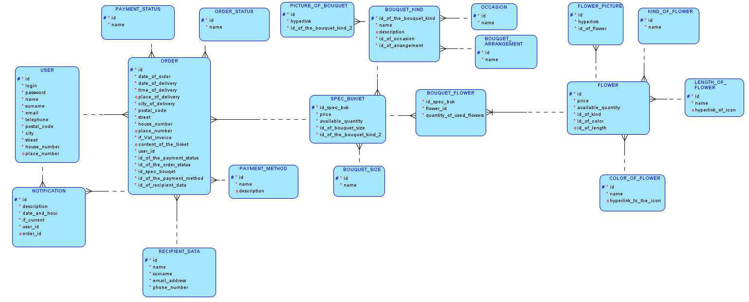

1. Relational data model:

